Document of the

Investment Promotion Service Center of

Jiyuan City-Industry Integration Demonstration Zone

JS [2023] No. 32



**Notice on Issuing the Measures of Jiyuan City for Handling Complaints from Foreign-invested Enterprises**

Administration offices of the Demonstration Zone, people’s governments of townships, sub-district offices, relevant municipal departments, and foreign-invested enterprises,

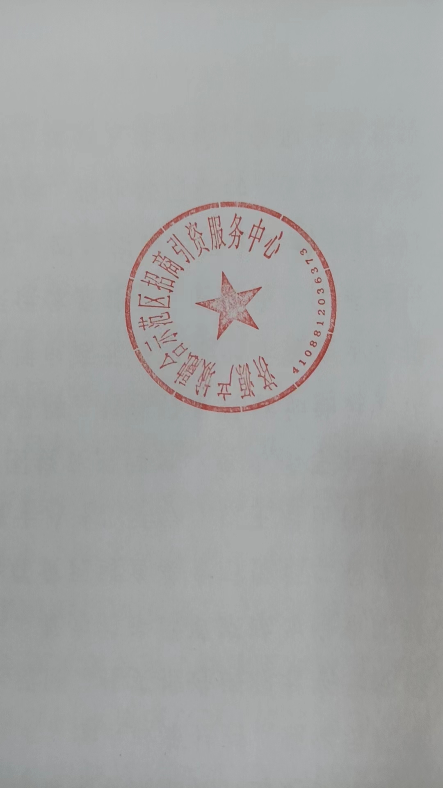The Measures of Jiyuan City for Handling Complaints from Foreign-invested Enterprises are hereby issued to you for your implementation.

The Investment Promotion Service Center of Jiyuan City-Industry Integration Demonstration Zone

DEC 06, 2023

**Measures of Jiyuan City for Handling Complaints from Foreign-invested Enterprises**

**Chapter I General Provisions**

**Article 1** These Measures are formulated in accordance with the Foreign Investment Law of the People’s Republic of China, the Implementing Rules of the Foreign Investment Law of the People’s Republic of China, Measures for Handling Complaints from Foreign-invested Enterprises (Order No. 3 [2020], Ministry of Commerce) and Measures of Henan Province for Handling Complaints from Foreign-Invested Enterprises (YZ [2021] No. 29), in combination with local conditions, to timely and efficiently handle complaints from foreign-invested enterprises (including foreign-invested enterprises or investors, the same below), safeguard their legitimate rights and interests, and continuously optimize foreign investment environment.

**Article 2** The term “complaints from foreign-invested enterprises” in these Measures refers to:

(a) The act that foreign-invested enterprises apply to the competent complaint handling body for resolution when they believe that their legitimate rights and interests are infringed upon by the administration of relevant departments in Jiyuan (including legally authorized public affairs administrative departments) and their personnel (referred to collectively as “the respondents”);

(b) The act that foreign-invested enterprises report on investment environment problems and suggestions on improving relevant policies and measures (including enterprise services, policy consultations, etc.) to the complaint handling body.

The term “complaint handling body” in these Measures refers to bodies responsible for accepting and handling complaints from foreign-invested enterprises, including the Foreign Investment Service Center of Jiyuan City and the complaint service departments in the administrative region.

**Article 3** The complaint handling body shall respond to complaints from foreign-invested enterprises promptly, fairly, impartially, and legally according to corresponding responsibilities at different levels and improve relevant policies and measures.

**Article 4** Foreign-invested enterprises should truthfully make their complaints, provide evidence, and assist the competent bodies in handling complaints.

**Article 5** The Investment Promotion Service Center of Jiyuan City-Industry Integration Demonstration Zone(referred to as the “Service Center”) is responsible for handling complaints from foreign-invested enterprises in the city. Its main responsibilities are as follows:

(a) Guiding, coordinating, and supervising the complaint handling work concerning foreign-invested enterprises in the city;

(b) Accepting and handling complaints from foreign-invested enterprises;

(c) Supervising the implementation of complaint handling decisions;

(d) Regularly briefing the acceptance and handling of complaints from foreign-invested enterprises;

(e) Organizing investigation and communication activities concerning complaints from foreign-invested enterprises;

(f) Providing legal and policy consulting services for foreign-invested enterprises and their investors.

**Article 6** The investment promotion bureaus or economic development promotion offices of administration offices of the Demonstration Zone, township governments, and sub-district offices are responsible for assisting in handling complaints from foreign-invested enterprises.

**Article 7** Foreign-invested enterprises’ application for mediation of dispute against administrative authorities in accordance with these Measures does not affect their rights to initiate an administrative review, administrative litigation, and other procedures within the statutory time limits.

**Article 8** Chambers of commerce and associations prescribed in Article 27 of the Foreign Investment Law of the People’s Republic of China may, by reference to these Measures, report to the complaint handling body the problems in the investment environment raised by their members and submit suggestions on policies and measures.

**Chapter II Complaints Filing and Acceptance**

**Article 9** Foreign-invested enterprises should submit written complaint materials when making complaints. Complaint materials can be submitted on-site or by post, fax, email, etc.

**Article 10** The Service Center and complaint service departments within the jurisdiction should publicize their addresses, telephone and fax numbers, email addresses, and other contact information for the sake of foreign-invested enterprises’ making complaints.

**Article 11** When a foreign-invested enterprise complains that the respondent’s administrative actions have violated its legitimate rights and interests and applies for appropriate resolutions to the complaint handling body, the complaint materials should include the following information:

(1) Name or designation, mailing address, postal code, relevant contacts, contact information of the foreign-invested enterprise, proof of its legal status and the date of the complaint;

(2) Name or designation, mailing address, postal code, relevant contacts, and contact information of the respondent;

(3) A clear list of complaint matters and claims;

(4) Facts, evidence, reasons, and any relevant legal basis, if available;

(5) Whether there are any circumstances listed in Items 6, 7 and 8 of Article 14 of these Measures.

When a foreign-invested enterprise reports on problems related to the investment environment and puts forward suggestions on improving relevant policies and measures, the complaint materials should include contents specified in Article 1.

The complaint materials should be written in Chinese. If such evidence and original documents are prepared in a foreign language, accurate and complete translations in Chinese should be submitted.

**Article 12** A foreign-invested enterprise may entrust other persons to file the complaint. In an agent case, materials submitted to the complaint handling body include proof of identity of the foreign investor or foreign-invested enterprise, the Power of Attorney, and identification of the authorized person, in addition to those specified in Article 11 of these Measures. The Power of Attorney should specify the matters, authority, and duration of the authorization.

**Article 13** The complaint handling body should notify the foreign-invested enterprises in writing within one working day after receiving the complaint materials if such materials are incomplete. The foreign-invested enterprise shall complete materials within seven working days. The notice should specify the items to be corrected and the deadline.

**Article 14** The complaint handling body shall not accept complaints in the following circumstances:

(1) The complainant is not a foreign-invested enterprise;

(2) The complaint is about a civil or commercial dispute against other natural persons, legal persons, or organizations, which is not within the scope of complaints from the foreign-invested enterprise as stipulated in these Measures;

(3) The complaint materials do not comply with provisions of Article 11 of these Measures even after being corrected in accordance with Article 13;

(4) The foreign-invested enterprise forges or falsifies evidence, or there is a lack of factual basis;

(5) Repetitive complaints submitted to the same complaint handling body without new evidence or legal basis;

(6) The same complaint matter has been accepted or concluded by a superior complaint handling body;

(7) The same complaint matter has been accepted or concluded by petition or other departments;

(8) The same complaint matter has entered or completed administrative review, administrative litigation, or other procedures.

**Article 15** After receiving complete and adequate complaint materials, the complaint handling body shall decide whether to accept the complaint within one working day.

Complaints meeting the acceptance conditions shall be accepted, and a notice of acceptance shall be issued to the foreign-invested enterprise.

If the complaint does not meet the conditions for acceptance, the complaint handling body shall issue a notice of non-acceptance to the foreign-invested enterprise within one working day, stating the reasons for non-acceptance. If it’s not a complaint matter within its jurisdiction, the complaint handling body shall make it clear in the notice.

**Chapter III Complaint Handling**

**Article 16** After accepting the complaint, the complaint handling body shall communicate and investigate thoroughly with the foreign-invested enterprise and the respondent and address issues properly and timely in accordance with the law.

**Article 17** The complaint handling body may require the foreign-invested enterprise to provide more details, materials or any necessary cooperation. The complaint handling body may also inquire about the fact and any necessary information with the respondent.

Depending on the specific circumstance of the complaint matter, the complaint handling body may organize a meeting with the foreign-invested enterprise and the respondent to reach a proper resolution. The complaint handling body may solicit expert opinions on professional issues if necessary.

**Article 18** Depending on the specific circumstance of the complaint matter, the complaint handling body may take the following measures:

(1) Facilitating an understanding and settlement between the foreign-invested enterprise and the respondent (including reaching a settlement agreement);

(2) Mediating with the respondent;

(3) Submitting suggestions on improving relevant policies and measures to the government and relevant departments;

(4) Adopting any other appropriate methods as deemed suitable

If a settlement agreement is reached between the foreign-invested enterprise and the respondent, it should specify the matters and results of the settlement. A settlement agreement entered into in accordance with the law is binding on the foreign-invested enterprise and the respondent. If the respondent fails to comply with a valid settlement agreement, it shall be subject to provisions of Article 41 of the Implementing Rules of the Foreign Investment Law of the People’s Republic of China.

**Article 19** The complaint handling body shall conclude the complaint matter within 7 working days from the date of acceptance. In cases involving multiple departments or complex situations, the handling period may be appropriately extended.

**Article 20** Complaint handling shall be terminated under the following circumstances:

(1) The foreign-invested enterprise agrees to terminate the complaint based on the mediation by the complaint handling body in accordance with Article 18 of these Measures;

(2) The complaint matter does not match the facts, or the foreign-invested enterprise refuses to provide materials, resulting in the inability to ascertain relevant facts;

(3) The appeal of the foreign-invested enterprise has no legal basis;

(4) The foreign-invested enterprise withdraws the complaint in writing;

(5) The foreign-invested enterprise no longer qualifies as the complainant;

(6) The foreign-invested enterprise does not attend to the complaint handling activities without valid reasons for more than 30 days after being informed by the complaint handling body.

During the complaint handling period, if any of the circumstances listed in Items 6, 7, and 8 of Article 14 of these Measures occur, it shall be deemed that the foreign-invested enterprise has withdrawn the complaint in writing.

After the conclusion of the complaint, the complaint handling body shall notify the foreign-invested enterprise of the complaint handling results in writing within one working day.

**Article 21** If a complaint has not been concluded in accordance with Article 20 of these Measures within one year from the date of acceptance, the complaint handling body shall promptly report it to the government at the same level and put forward work suggestions.

**Article 22** If a foreign-invested enterprise disagrees with the decision of the complaint handling body to reject the complaint or with the complaint handling results, it may file the original complaint to higher authorities step by step. The higher-level complaint handling body may decide whether to accept the original complaint based on its complaint handling rules.

**Chapter IV Complaint Management System**

**Article 23** The complaint handling body shall improve its internal management systems and take effective measures in accordance with the law to ensure the security of the trade secrets, confidential business information, and personal privacy of foreign-invested enterprises during the complaint handling process.

**Article 24** The complaint handling body shall establish a complaint file management system to enable timely, comprehensive, and accurate records of complaint acceptance and handling and archive such files by year.

**Article 25** The complaint handling body shall report on its complaint handling work to the provincial-level competent body every two months, including the number of complaints received, progress in handling, details of resolved complaints, and policy suggestions.

**Article 26** During the complaint handling process, the complaint handling body may report to the Service Center any common issues found in local or departmental work or any violations of laws and regulations or improper contents in administrative normative documents and put forward corrective measures.

**Article 27** The Service Center shall establish a regular system to oversee the complaint handling work involving foreign-invested enterprises and promptly report on the progress.

**Chapter V Supplementary Provisions**

**Article 28** Complaint handling bodies and their staff that abuse their power, neglect their duties, engage in malpractices for personal gain, or disclose or illegally provide others with the trade secrets, confidential business information and personal privacy they have learned in the process of complaint handling shall be subject to Article 39 of the Foreign Investment Law of the People’s Republic of China.

**Article 29** No unit or individual shall suppress or retaliate against the complainant who complains or applies for resolutions through the complaint mechanism for foreign-invested enterprises.

**Article 30** Complaints against the administrative organs of Jiyuan and their staff at all levels by investors from Hong Kong Special Administrative Region, Macao Special Administrative Region, Taiwan region, and enterprises invested by Chinese citizens residing abroad shall be handled with reference to these Measures.

**Article 31** These Measures shall come into force from the date of promulgation.

|  |
| --- |
| The Investment Promotion Service Center of Jiyuan City-Industry Integration Demonstration Zone |
| Issued on Dec 06, 2023 |